Get Engaged …You will experience a life changing event and join youth across the nation in their efforts to end world hunger. During the **Rise Against Hunger Love Hungry**

4-week sessions, you will learn what God has to say about poverty and hunger through scripture, videos of Mahana’s life, activities, games and service projects. Giving up food, allows your eyes (and stomachs!) to be opened to daily realities of hunger and poverty faced by children and families around the world. By loving hungry, you will deepen your understanding of poverty and grow in faith.

**Schedule:**

**Sun. Feb. 5th** - Tribal Kickoff, Mahana’s food & economic empowerment.

**Sun. Feb. 12th** - RAH Love Hungry Fundraiser – Souper Bowl of Caring

**Sun. Feb. 19th** – Mahana’s shelter, education & health

**Sun. Feb. 26th –** Mahana’s water,safety, final refection and closing ceremony.

**Benefit:** Aside from helping to feed hungry children around the world, participation in the Rise Against Hunger Love Hungry Famine can help students earn community service hours for school and other youth programs.

How we will Love Hungry:

In the month of February, the Jr. & Sr. High TWIGS youth group will come together to Rise Against Hunger and love Hungry. During these 4-week sessions, youth will learn and feel what hunger and poverty looks like. Through video’s of Mahana’s life the youth will participate in Tribal simulation challenges, games and activities all while raising money to feed hungry kids around the world. Topics will include:

Food, economic empowerment, shelter, education, health, water and safety. Youth are encouraged to fast the days we meet and eat following our meeting.

We are asking youth to set a goal for the amount they would like to raise. Each meal bag that we will pack on May 13th containing rice, soy, vegetables and vitamins cost approx. $40 and will feed 10 children.

My Goal

I would like to raise _________, which is __________ meal bags providing meals for ______ children.

What’s Next:

Register to help at the

Rise Against Hunger Meal Packing Event on **Sat. May 13th 2023 10-12pm**

Meet Mahana

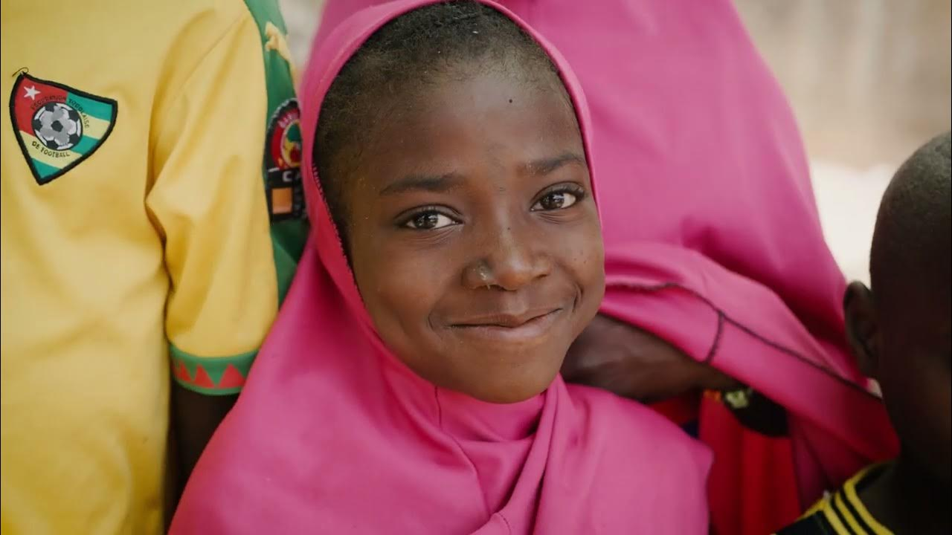

The world is experiencing its worst hunger crisis in decades. Conflict, COVID-19, and climate change are driving a deadly crisis around the world.

Mahana age 9 lives in Niger; a country ranked last on the human development index. Life expectancy is low, poverty is high, they are currently living through a year-long drought, and only about half of the population has access to clean water. Mahana’s family rarely has enough food to eat. Sometimes, she only has one meal per day or none at all. Mahana’s community is struggling, but they stick together and have hope that one day things will be better. With your efforts, you help to provide access to much needed clean water, food, farming skills and other essentials needed to live.