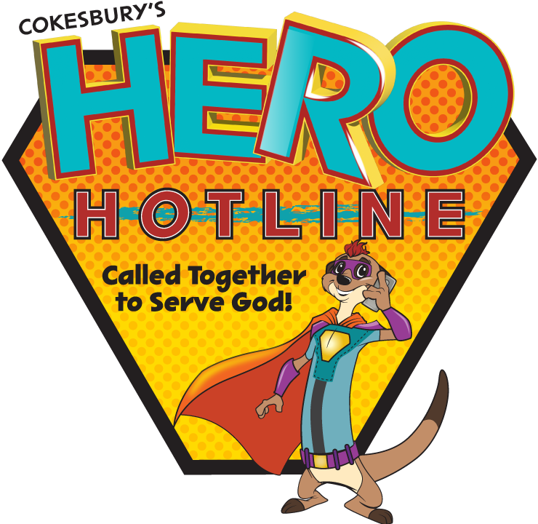
Endwell UMC 3301 Watson Blvd. Endwell NY 13760
VBS Registration Form - July 9-13th 6-9pm preschool – 6-8pm
Crew Name________________________________________________ (for church use)

(Please print)

Child’s Name________________________________________________________

OK to photo/video

__yes __No

Permission to slip‘n slide __yes __no

Grade Completed/Age______/_______ Date of Birth______________________

Address: ____________________________________________________________

City: ___________________ Zip____________ Phone: _______________________

Email: ______________________________________________________________

Emergency Contact: ____________________ Cell#___________________________________________________

Person picking child up from VBS____________________________________ Relation: ____________________

Allergies- special needs - medical conditions: _________________________________________________________

Home Church: ___________________________________________________________

Endwell UMC 3301 Watson Blvd. Endwell NY 13760
VBS Registration Form – July 9–13th 6-9pm preschool – 6-8pm Crew Name___________________________________________________(for church use)

(Please print)

Child’s Name________________________________________________________

OK to photo/video

__yes __No

Permission to slip‘n slide __yes __no

Grade Completed/Age______/_______ Date of Birth______________________

Address: ____________________________________________________________

City: ___________________ Zip____________ Phone: _______________________

Email: _______________________________________________________________

Emergency Contact: ____________________ Cell#____________________________________________________

Person picking child up from VBS____________________________________ Relation:______________________

Allergies – special needs - medical conditions: ________________________________________________________

Home Church: __________________________________________________________

