DLTK's Crafts for Kids
Platypus Toilet Paper Roll Craft
A platypus is mammal that lays eggs like a bird and has a beak like a bird. In fact, it was so strange to scientists back in the 18th century that they thought someone was playing a joke on them. This is a fun platypus craft that children can make to remind them of God’s sense of humor. Can you think of other things in nature that make you laugh?

Materials:
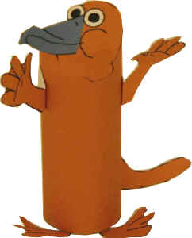
toilet paper roll or cardboard tube,
a printer,
something to color with,
scissors,
glue,
paper
Instructions:
Print out the craft template below.
Color and cut out the template pieces.
Glue the large rectangular piece on first to cover the tube. Toilet paper rolls come in different sizes, so if you find the rectangle is a bit too big, just trim it down. If you find it's a bit too small, just cut out another small piece to fill in the gap.
Glue the tail onto the back of the toilet paper roll using the tabs to make a 3D effect.
Glue the head onto the front of the toilet paper roll.
Glue on the arms and legs.
Have fun playing with your platypus!!

