

Imagine a better world!

Imagine a world of abundance where there is enough for all. During theses

4-week sessions, you will be part of bringing God’s care to hungry kids around the world. Through the **Rise Against Hunger Love Hungry** sessions, you’ll get to learn about how poverty steals people’s choices, holding them back from all God made them to be. You’ll find out what Global hunger really looks like, and why so many people don’t have everything they need. You’re fundraising efforts for Rise Against Hunger, is your first step to do something about it. Together, we’re on a mission to live in a world where there is enough food for all. With God’s help, let’s Rise Against Hunger together.

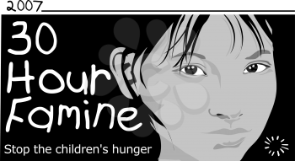

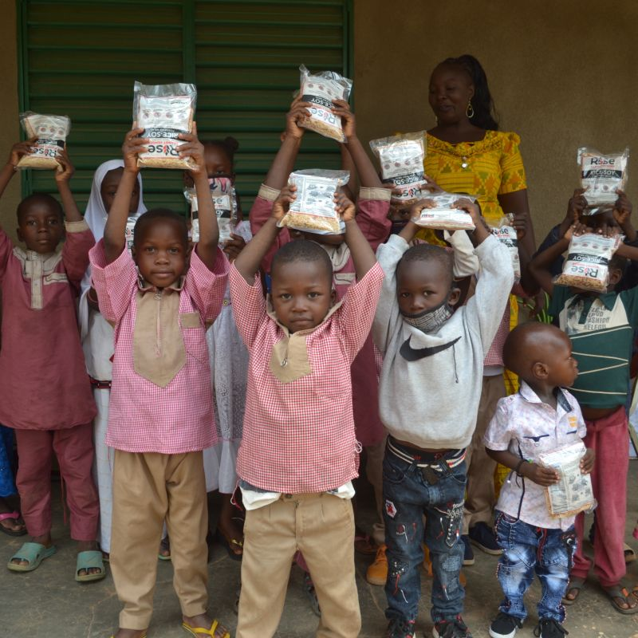

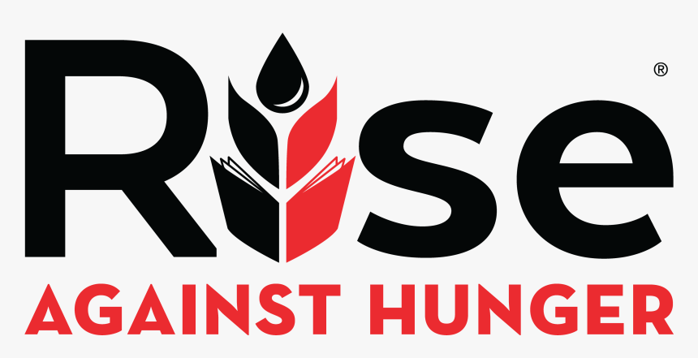

It Starts with a meal.

24



Fundraising Tips

Ask friends and family for donations on the phone, text or email.

**Script:** I’m really excited to participate in the **Rise Against Hunger Love Hungry Famine**. During 4-weekly sessions I will be learning about the impact of global hunger and giving up food to raise money for our upcoming Rise Against Hunger Meal packing event on

**Saturday May 13, 2023 to** - help feed hungry kids around the world. During our Love Hungry sessions, we’ll learn about global hunger and poverty and get a glimpse of how it feels to be hungry. Every day over 7,000 kids die from hunger-related causes. At the RAH meal packing event I will help to pack 20,000 meals containing rice, soy, vitamins and minerals which provide nutritional support to children and families around the world. Along with providing meals, Rise Against Hunger provides safety net programs that supports education, skills training and health services in a global effort to end world hunger. My goal is to raise ______ Would you be willing to support my efforts and make a donation?

[www.rootedateumc.org/riseagainsthunger](http://www.rootedateumc.org/riseagainsthunger)

Go to: click on the Rise Against Hunger logo linking you to the Endwell UMC donation page. Thank You!