Definition:
Name Date
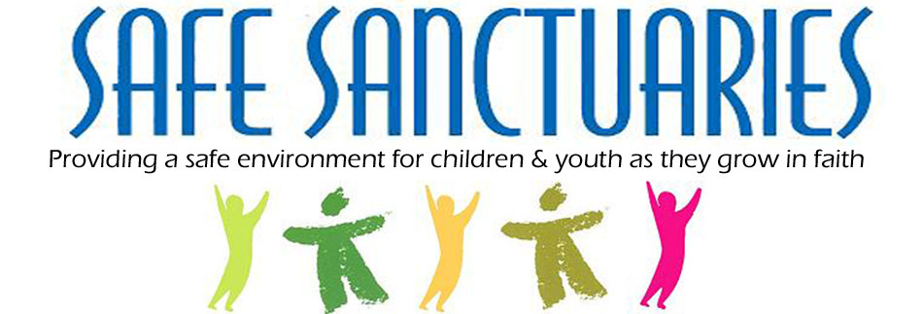CDC- What is Child Abuse and Neglect?
Any act or series of acts of commission or omission by a parent, caregiver or another person in a custodial role that causes harm, potential for harm or threat of harm to a child. A preventable act

What are acts of commission?

Examples of Acts of commission:
1. 2. 3.

What are acts of omission?

Examples of acts of omission:
1. 2. 3.

4. 5. 6.

What can we do?

What are the 5 strategies to consider in preventing child abuse and neglect?
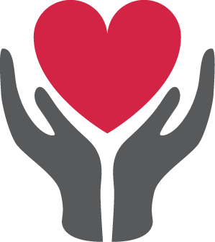

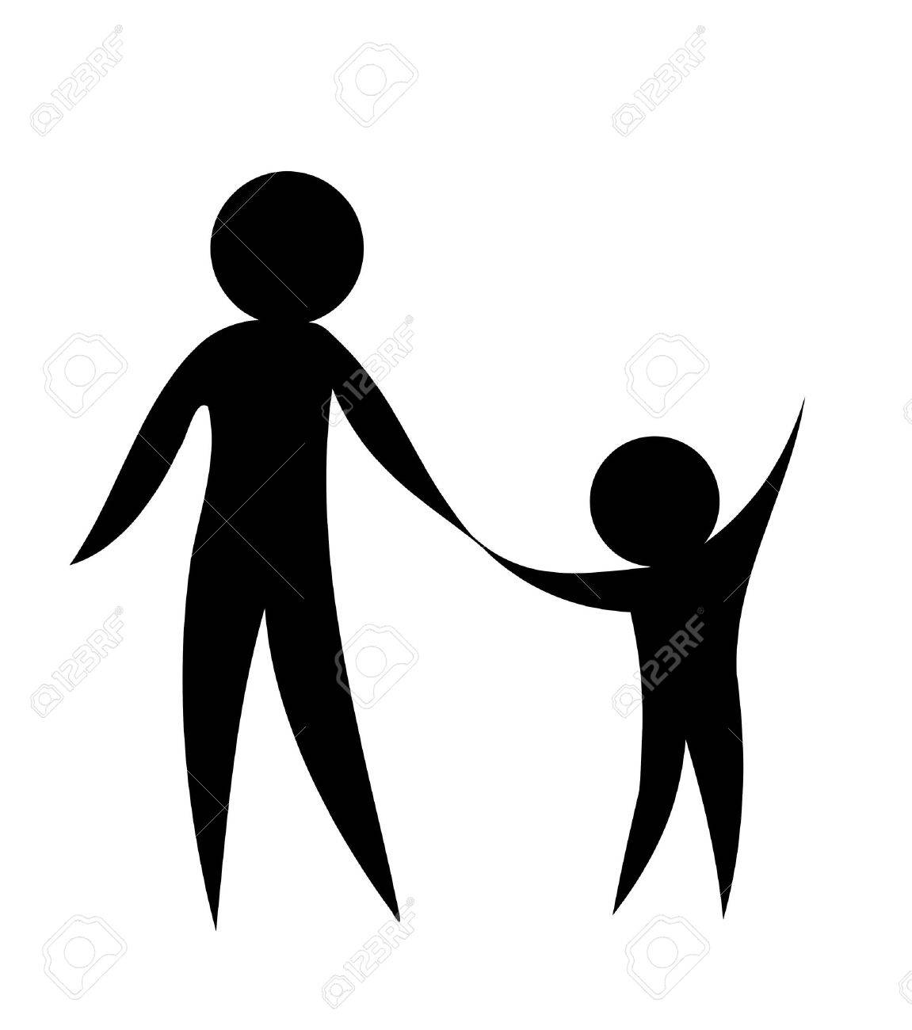
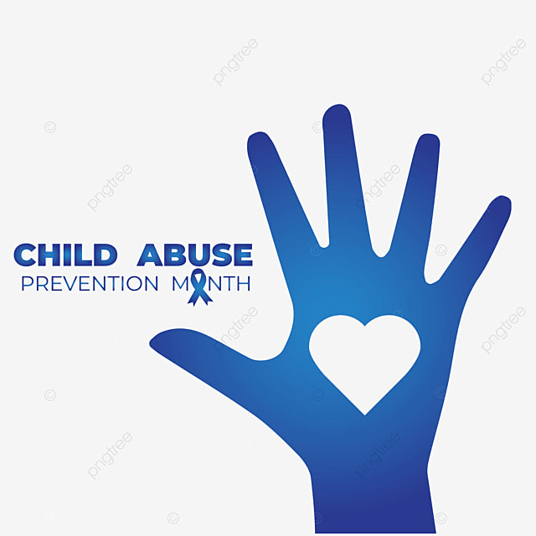

Together let’s prevent child abuse and neglect by building stronger families and safer communities where every child thrives.

