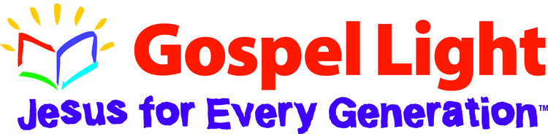
Gospel Light Book: Scripture: Bible Point: Lesson #/page:

Introduction:

Tell the Bible Story/ Snack

Activity Center: Collect:
Prepare:

Talk About it:

Closing Prayer:

